**Azure fundamental assignment 1**

1. **What is cloud computing? What is Azure?**

**Cloud computing** is the delivery of computing services—including servers, storage, databases, networking, software, analytics, and intelligence—over the Internet (“the cloud”) to offer faster innovation, flexible resources, and economies of scale. You typically pay only for cloud services you use, helping lower your operating costs, run your infrastructure more efficiently and scale as your business needs change.

The **Azure** cloud platform is more than 200 products and cloud services designed to help you bring new solutions to life—to solve today’s challenges and create the future. Build, run and manage applications across multiple clouds, on-premises and at the edge, with the tools and frameworks of your choice.

At its core, Azure is a public cloud computing platform—with solutions including **Infrastructure as a Service** (IaaS), **Platform as a Service** (PaaS), and **Software as a Service** (SaaS) that can be used for services such as analytics, virtual computing, storage, networking, and much more. It can be used to replace or supplement your on-premise servers.

1. **How to create an Azure account list the steps and requirements?**

1. Go to the [**Azure Home Page**](https://azure.microsoft.com/en-us/).

2. Click on **Free Azure Account** on the top right corner.

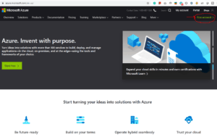

3. Click on **Start Free.**

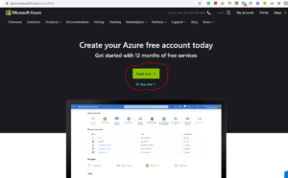

4. Sign-in/Sign-up for a Microsoft account using an email address and password.

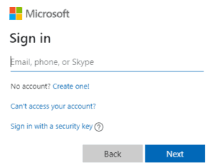

5. Enter your Country/Region and Date of Birth and click next.

6. Enter the **verification code** received on the email address and click next.

7. Type the captcha you see on your screen and click on next.

8. You’ll be redirected to the Azure Sign-up page. Enter your Region, Name, Phone number, Email address. **Note**: You should use the same email address for Azure sign-up and for the Microsoft account.

9. Verify your phone number by clicking Text Me or Call Me and enter the verification code received.

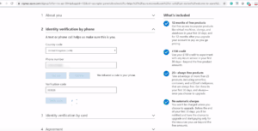

10. Enter the payment details. Make sure you have a **Master Card/American Express/ Visa Credit card** and international payments should be enabled.

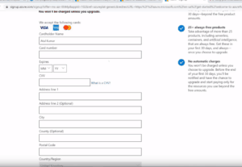

11. Check the Terms and Conditions and click Sign-up.

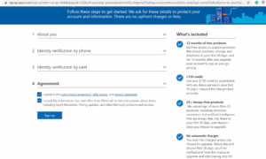

12. You have successfully created a Microsoft Azure free account and now have a lumpsum balance of **$200**.

13. Click on **Portal** on the top right corner of the screen. You’ll be redirected to the Azure portal.

14. If you have exhausted your free credit then you have to move to the Pay as you go subscription policy.

if you have crossed the limit or time limit then you will get “your subscription is disabled and cannot perform operations  until its re-enabled”

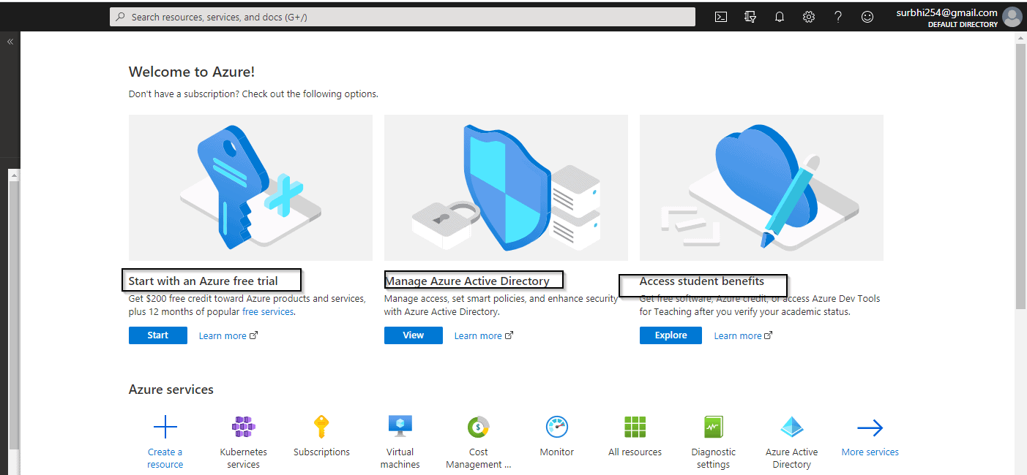

You can not create multiple Microsoft azure free accounts or after one account expires to another account for free credit of 200$ using a single Credit card.

1. **Describe different types of cloud models.**

There are three main types of cloud environment, also known as cloud deployment models. Businesses can choose to run applications on public, private or hybrid clouds – depending on their specific requirements.

**Public Cloud**

A public cloud environment is owned by an outsourced cloud provider and is accessible to many businesses through the internet on a pay-per-use model. This deployment model provides services and infrastructure to businesses who want to save money on IT operational costs, but it’s the cloud provider who is responsible for the creation and maintenance of the resources.

Public clouds are ideal for small and medium sized businesses with a tight budget requiring a quick and easy platform in which to deploy IT resources.

**Private Cloud**

This cloud deployment model is a bespoke infrastructure owned by a single business. It offers a more controlled environment in which access to IT resources is more centralised within the business. This model can be externally hosted or can be managed in-house. Although private cloud hosting can be expensive, for larger businesses it can offer a higher level of security and more autonomy to customise the storage, networking and compute components to suit their IT requirements.

**Hybrid Cloud**

For businesses seeking the benefits of both private and public cloud deployment models, a hybrid cloud environment is a good option. By combining the two models, a hybrid cloud model provides a more tailored IT solution that meets specific business requirements.

1. **Describe different cloud services.**

**1. Infrastructure as a Service (IaaS)**

This the most commonly used cloud computing service model owing to its structural support that includes virtual servers, operating systems, network, and data storage drives. The IaaS model caters to the businesses’ basic need for scalability, flexibility, and reliability vis-a-vis the cloud, as well as obliterates the need for maintaining hardware in the office space. It is a completely outsourced service that operates on a pay-for-use model and is available in private, public, and hybrid infrastructure formats.

Given the specialization and scale involved, IaaS can be a profitable model for businesses using it as well as vendors providing it. Using IaaS inevitably brings in an element of complexity, but it also gives the user unparalleled flexibility. The IaaS model is, therefore, best suited for small and medium organizations that need cost-effective yet easily scalable IT solutions capable of supporting business growth.

**2. Platform as a Service (PaaS)**

This cloud computing model deploys software and infrastructure framework offered by the cloud service providers with room for businesses to develop and run applications of their own as well. PaaS clouds are developed within IaaS clouds in many cases by specialists with a view of scaling the process of application deployment, making the users’ expenses highly predictable. With PaaS, web applications can be developed with ease and in a time efficient manner, and the cloud service carries the requisite robustness and flexibility to support the process.

One of the key benefits of this service is that you can initiate an application with next to no monetary investment. All you have to deal with is essential development (or port, in case of an existing application). PaaS also facilitates scalability by nature of its design, making it suitable for organizations that want to maintain a lean operations staff. It is ideal for business setups that revolve around either leveraging existing data sources or involve projects that require inputs from multiple developers.

**3. Software as a Service (SaaS)**

SaaS is relatively knowledgeable service, and the use of the term predated cloud computing. In this service model, applications leverage the cloud for software architecture, thus, cutting back significantly on burdens of operations, support, and maintenance. This is made possible by running applications on vendor computer as opposed to that of the user. This service makes software available to various users over the internet who, then pay for it either by signing up for a subscription or via a pay-per-use model.

Since SaaS is managed from centralized locations, organizations deploying this service are not concerned with its maintenance. It can prove to be a valuable tool for CRM, as well as apps that require extensive mobile or web access. SaaS is also the ideal cloud computing service for short-term projects.

1. **What are some cloud computing advantages?**

1) Back-up and restore data

Once the data is stored in the cloud, it is easier to get back-up and restore that data using the cloud.

2) Improved collaboration

Cloud applications improve collaboration by allowing groups of people to quickly and easily share information in the cloud via shared storage.

3) Excellent accessibility

Cloud allows us to quickly and easily access store information anywhere, anytime in the whole world, using an internet connection. An internet cloud infrastructure increases organization productivity and efficiency by ensuring that our data is always accessible.

4) Low maintenance cost

Cloud computing reduces both hardware and software maintenance costs for organizations.

5) Mobility

Cloud computing allows us to easily access all cloud data via mobile.

6) IServices in the pay-per-use model

Cloud computing offers Application Programming Interfaces (APIs) to the users for access services on the cloud and pays the charges as per the usage of service.

7) Unlimited storage capacity

Cloud offers us a huge amount of storing capacity for storing our important data such as documents, images, audio, video, etc. in one place.

8) Data security

Data security is one of the biggest advantages of cloud computing. Cloud offers many advanced features related to security and ensures that data is securely stored and handled.

1. **Differentiate Capital expenses vs. operating expenses**

|  |  |  |
| --- | --- | --- |
|  | **Capex** | **Opex** |
| **Definition** | Capital expenditures are expenditures creating future benefits. A capital expenditure is incurred when a business spends money either to buy fixed assets or to add to the value of an existing asset with a useful life that extends beyond the tax year. | OpEx (Operational expenditure) refers to expenses incurred in the course of ordinary business, such as sales, general and administrative expenses (and excluding cost of goods sold - or COGS, taxes, depreciation and interest). |
| **Also known as** | Capital Expenditure, Capital Expense | Operating Expense, Operating Expenditure, Revenue Expenditure |
| **Accounting treatment** | Cannot be fully deducted in the period when they were incurred. Tangible assets are depreciated and intangible assets are amortized over time. | Operating expenses are fully deducted in the accounting period during which they were incurred. |
| **In throughput accounting** | Money spent on inventory falls under capex. | The money spent turning inventory into throughput is opex. |
| **Examples** | Buying machinery and other equipment, acquiring intellectual property assets like patents. | Wages, maintenance and repair of machinery, utilities, rent, SG&A expenses |
| **In real estate** | Costs incurred for buying the income producing property. | Costs associated with the operation and maintenance of an income producing property. |
| **Procurement Involvement** | Purchasing rarely takes the lead, but only assist in the procurement of the item. The negotiation process also takes much longer. | Everyday items bought on a regular basis and minimum stock levels kept. It also does not incur any maitenance cost or repair |